STUDENT Joseph Roper

Salford City College | [Company address]

BTEC National 90 Credit Diploma in Creative Media Production

Unit 1: Pre-production Techniques

Contents

Game Outline 2

How to start an Indie Game Business? 2

Resource List & Budget Analysis 3

Risk Assessment 6

My Risk Assessment 6

S.W.O.T Analysis 7

My S.W.O.T Analysis 7

Recce Report 7

Recce Report Example 7

My Recce Report 8

Prototype Design 9

My Prototype Designs 10

My Assets 11

Why Planning is Important? 11

Why it is Important for Business? 11

Why it is Important for Myself? 11

Sources 11

# Game Outline

Company Name: Wrong Way (Games)

Game Name: Unknown

Gameplay: Text based RPG Adventure

Opening: You awake in a forest on a pile of leaves not knowing where you are, who you are or what you are doing, you are completely confused. You eventually pull yourself up and start your adventure trying to find out your identity.

Twine Coding: I am going to use the latest version of Sugarcube on Twine as my coding language.

# How to start an Indie Game Business?

From searching the internet for knowledge on how to start an indie game company, firstly I have realized that it is hard work, a lot of hard work and more importantly that money is everything so having a financial plan and keeping on top of bills is a must if you ever have hope of your company succeeding. A financial plan will make it, so you know exactly how far your budget will take you and whether you will need to gain more capital for your business. Without a financial plan you will most likely run out of budget before you ever make progress with the development of your game.

# Resource List & Budget Analysis

Overall my business will need roughly £280,510.93 and here is why.

|  |  |  |  |  |
| --- | --- | --- | --- | --- |
| Item | Price | Amount | Total | Picture/Link |
| Chair | £39.99 | *4 | £156.96 |  |
| Desk | £73.99 | *4 | £295.96 |  |
| Office PC Bundle: Computer, Monitor, Mouse & Keyboard | £479 | *4 | £1,916 |  |
| Photoshop | Per Year: £303.36 | *4: 2 Computers for 2 years. | £1,213.44 |  |
| Aseprite: This is a pixel art creation app. | $14.99 | *4 | $59.96  =  £44.58 | **[https://lh4.googleusercontent.com/b7Jq2b2W3y-HJqifGfGrZIRPA_2ytYoCpUaTgaRkxVNr2B0ZyKHrtHxHUuN2UTbkm6x1sQE-pcN6vrRi4y_mAeBQo12zqx50BQ3j2zEIIIrMEux6gOLsLUZYyMybRJWtgtxQozyf](https://www.aseprite.org/#buy)** |
| Office 365: Word, Excel, PowerPoint, Outlook, OneNote, Publisher and Access. | £79.99 per year | *1 because you can have 5 users at once | £79.99 |  |
| Office in Manchester | £250.00 per month | *12 to get a year the *2 to get 2 years | £6,000 |  |
| I will have a team of 4.  1 Programmer | £30,402 per year | *2 to get 2 years pay | £60,804 |  |
| 1 Artist | £35,000 per year | *2 to get 2 years pay | £70,000 |  |
| 1 Musician | £30,000 per year | *2 to get 2 years pay | £60,000 |  |
| Then myself as another programmer but also a story writer. | £40,000 per year | *2 to get 2 years pay | £80,000 |  |

# Risk Assessment

What is a risk assessment? A risk assessment is a list or table containing potential risks that can happen in a workplace or when working on a project. This is useful as it can stop accidents from happening in the workplace, for example if in a risk assessment it said don’t leave wires going across the floor because someone could trip over, this will mean workers won’t leave wires on the floor causing no one to trip over the wire, fall and get hurt.

**[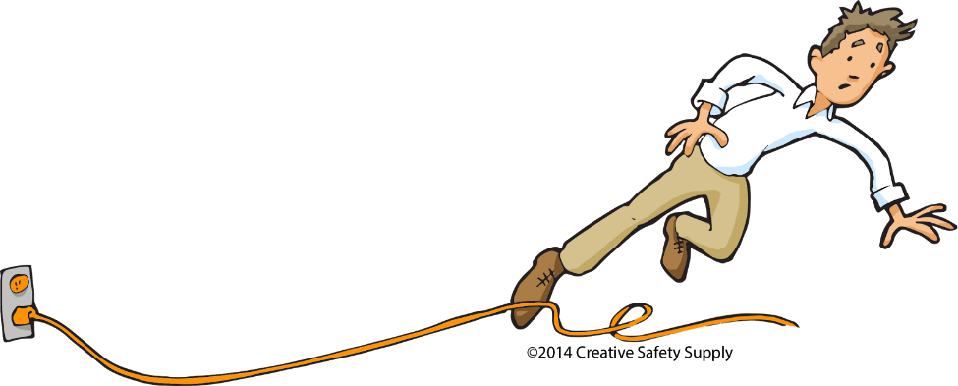](https://blog.creativesafetysupply.com/workplace-safety-hazards-the-5-hidden-dangers/)**

# My Risk Assessment

|  |  |  |  |
| --- | --- | --- | --- |
| Identified Risk | Who would be harmed? | Solution | What would the solution cause? |
| Work is not saved. | Everyone | Turn auto save on and save regularly. | Work will not be lost which will keep staff motivated. |
| Work is not easily accessible. | Everyone | Save work to the cloud such as OneDrive or google drive. | It would make it, so work is accessible from anywhere, even if someone is sick they can work a little bit from home, also you will always know where work is stored. |
| The game getting leaked. | Everyone | Use code names for all work. | It will make it, so work is not stolen or copied by other game developers. |
| Losing work. | Everyone | Keep up to date backups | This will make it so if by any chance work is deleted or lost the backup will be available to work on. |
| Wires on the floor. | The person who trips over the wire. | Don’t have wires going along the floor or protect them with a cable cover. | It would mean no one would trip over wires and harm themselves keeping motivation and work flow up. |
| Risk of a fire or damaging equipment. | Everyone | Turn off all outlets when closing the up the office. Perform regular maintenance checks. | Equipment will not be damaged. Fires will not be started. Electricity will not be wasted so bills will be lowered. |
| Lack of health and safety knowledge. | Everyone | All staff members should be trained in health and safety by attending conferences. | If someone is cut everyone knows how to bandage the wound. Everyone will know if something is safe. |

# S.W.O.T Analysis

S.W.O.T is an acronym for Strengths, Weaknesses, Opportunities and Threats so S.W.O.T analysis is where you analyse these things. S.W.O.T Analysis is used everywhere in the business market as it can help you progress in your career as you have your weaknesses to improve or avoid written down for you to always see.

## My S.W.O.T Analysis

What are your businesses strengths? - Determination, charisma, enthusiasm, no publishers changing our idea - no true deadlines.

What are your weaknesses? - First company and my first game, lack of experience - limited budget and resources.

What are your opportunities? - Game jams - gaming conventions, your tubers for promotion.

What are your threats? - lacking experience might not be able to do some things we want to because of time, budget.

# Recce Report

Recce short for reconnaissance and is mainly used in film production as people would visit locations to see whether it is worth filming there. When making a recce report you need to think of things such as where will the lighting equipment go, is there any water, electricity, heating and internet, what equipment will be needed such as if the room has an echo, acoustic foam will need to be installed on site to dampen the noise and echo.

## Recce Report Example

This is an example of a recce report for a bar which would be used for filming in, as you can see images of the bar were put on the report and there are many more on the website. This is a good recce report as it explains why the bar would be a good place to film in as the owner would “**allow access to a power supply and would allow us to use all of the props we have intended or help create the desired lighting effect” they also said how they acquired the permission to film in the bar as the bar is part of a rugby club which is friends with the sports college they attend. Also, the recce report is improved with the health and safety concerns they added.**

This report will be useful to me as I can use it as a guide for when I make my own recce report by including health and safety concerns, how I will use the site for my game and how I will get permission to use the site.

[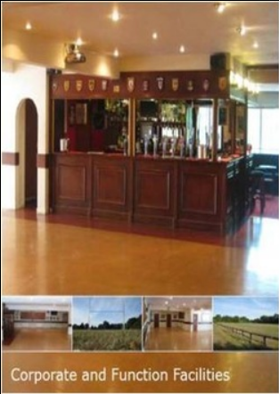](https://thejohnfisherschoola2mediastudies.weebly.com/recce-report.html) [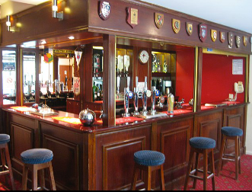](https://thejohnfisherschoola2mediastudies.weebly.com/recce-report.html)

## My Recce Report

This will be a recce report of a river which I think will be a perfect place to put in my game. The river is in my local forest, so it is ok to use in a game as I don’t need permission. I thought this would be a great place for a boss battle to be held as the boss could drop down from the top of the waterfall and then the fight would commence, and you would be able to use objects from the river such as climbing up trees to dodge attacks picking up and throwing rocks at the boss and again pull-down trees then let go to slap the boss with a branch.

I believe the health and safety concerns would be that as seen from the pictures the rocks have moss growing on them making the rocks wet meaning that if someone were to step onto the rocks they could slip, to stop this when recording data of the waterfall and river I should take caution and wear appropriate footwear i.e.: wellies or hiking boots which would make it less likely for myself to slip.

To record data, I will take further pictures of the forest, river and waterfall with my camera to later turn into a 3D environment in my game.

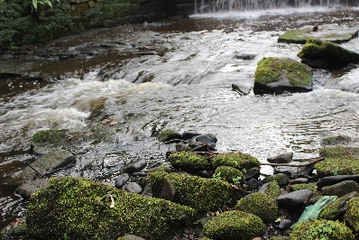 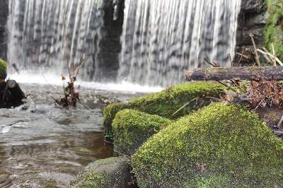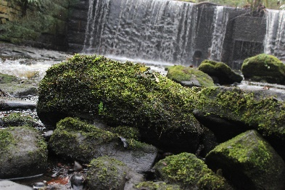

# Prototype Design

Prototypes are needed in game development as they help you plan out what your characters will look like. A method of this is concept art.

[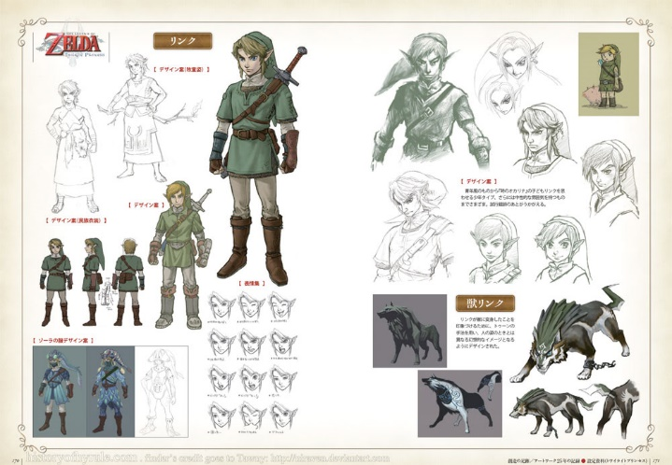](http://www.theconceptartblog.com/2012/05/07/hyhule-historia-zelda-25th-anniversary/)Concept art is used in pre-production to show ideas and in games design it is mainly used to show the developers preliminary ideas for characters and enemies in the form of drawing. Concept art is also used in films, animation and well everything which contains drawings such as architecture. Concept art is just illustrations that convey an idea, mood, character, colour scheme and or the overall style of the game. Concept art starts off as rough sketches and with time they are revisited and perfected/optimised and left as final ideas and are usually released to the public.

As you can see this picture shows the early stages of concept art and the final design for the character Link in The Legend of Zelda: Twilight Princess.

## My Prototype Designs

For my designs I made a mood board to help plan out what the assets would look like.



[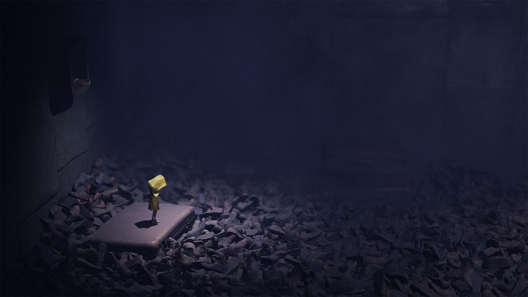](https://uk.gamesplanet.com/game/little-nightmares-steam-key--3162-1)[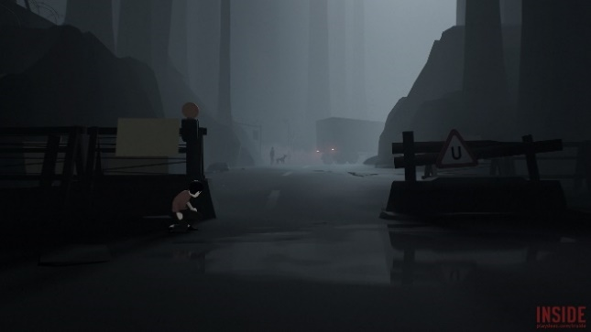](https://waypoint.vice.com/en_us/article/vvkzz8/the-unifying-monstrous-hopefulness-of-inside)

[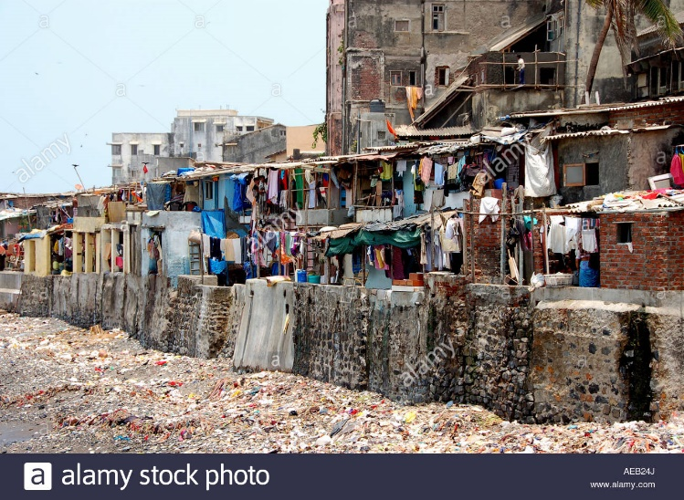](http://www.alamy.com/stock-photo-shanty-town-in-mumbai-or-bombay-viewed-from-a-taxiing-aircraft-at-78006577.html)[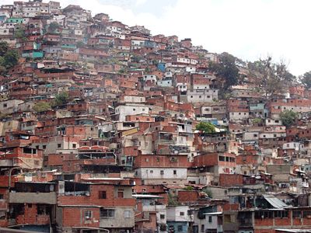](https://propertydrum.briefyourmarket.com/Article.aspx?id=558)[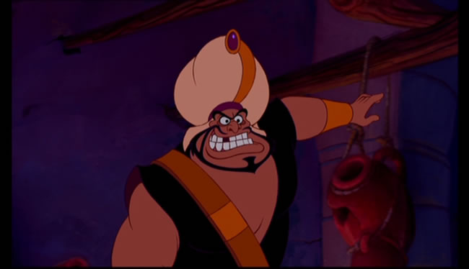](http://aladdin.wikia.com/wiki/Razoul)

## My Assets

As you can see I took a lot of inspiration from my mood board especially with the guard. My mood board helped me plan my assets out, so I had a clear vision throughout the designing process.

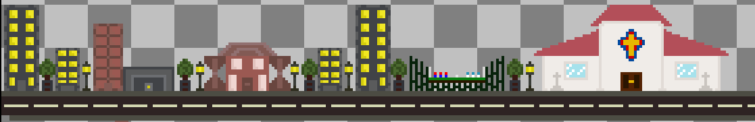

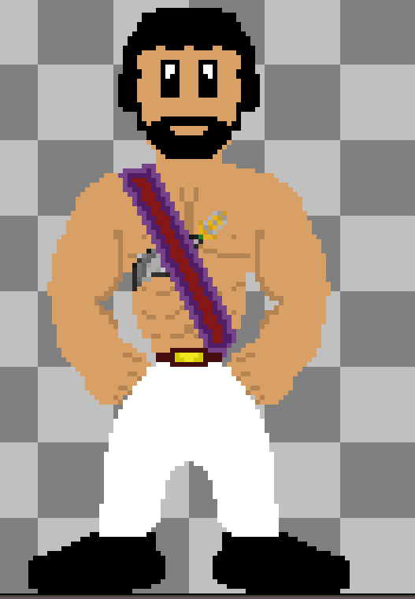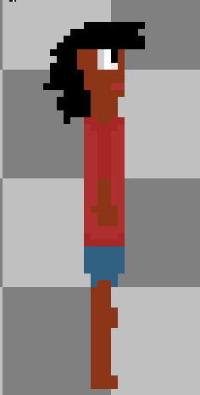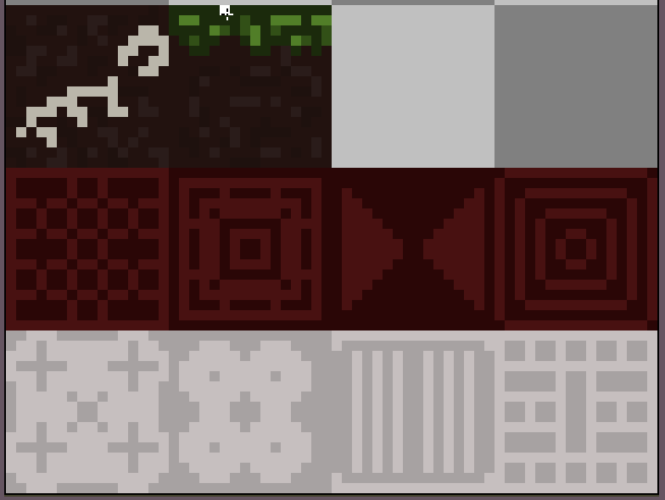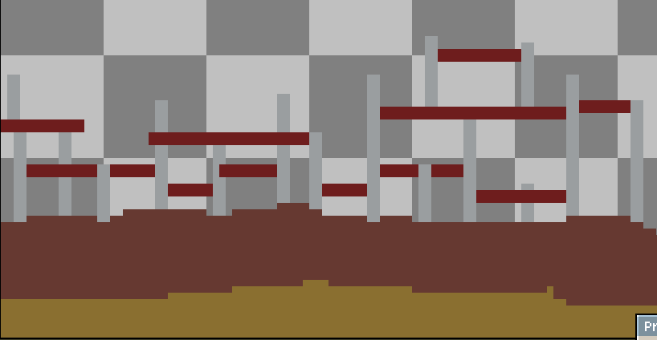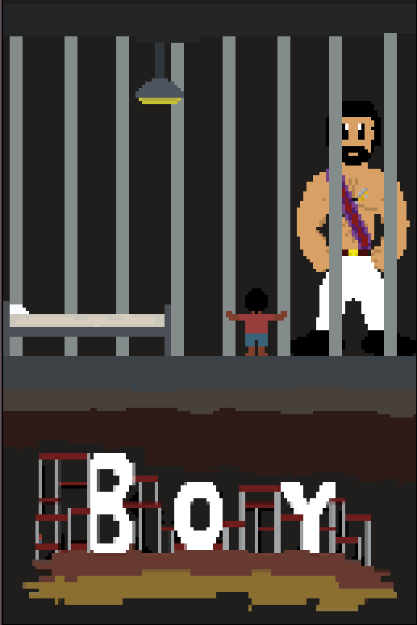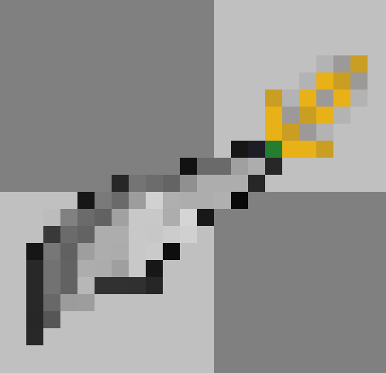

# Why Planning is Important?

## Why it is Important for Business?

Planning is especially important in a business as if you plan everything out: workflow, production quality and motivation will increase as workers will know exactly what to do for each step of their work which in turn will also decrease the amount of errors in their work.

## Why it is Important for Myself?

Planning all my assets helped a lot with my work as it set out a clear plan with what I had to do for each asset I made. For example, with my guard sprite I planned it out by taking inspiration from the head guard out of the movie Aladdin as you can clearly see from my mood board, then I trace out a minimalistic skeleton of the guard, then I began making the character while constantly referring to the picture of the guard out of Aladdin while also keeping the colours of the guard like my colour pallet in my mood board. So, from planning out my character I was able to make consistent progress in making my character than I would normally if I didn’t plan out a character.

# Sources

Recce Report Example - <https://thejohnfisherschoola2mediastudies.weebly.com/recce-report.html>

S.W.A.T Analysis - <https://www.mindtools.com/pages/article/newTMC_05.htm>

<https://en.wikipedia.org/wiki/SWOT_analysis>

<https://articles.bplans.com/how-to-perform-swot-analysis/>

How to start an Indie Game Business - <https://www.gamasutra.com/blogs/AlexPetlenko/20160307/267328/Starting_Your_Own_Game_Development_Studio__One_Year_On.php>